# [**Date set for Benson and Stabler reunion in ‘Law & Order’ crossover event**](https://www.nydailynews.com/snyde/ny-april-1-benson-stabler-law-and-order-svu-reunion-crossover-event-20210205-wuu5e35tnrggfcwtpjjjcxsh7e-story.html)

**By** [**KARU F. DANIELS**](https://www.nydailynews.com/ny-karu-f-daniels-staff.html#nt=byline)

NEW YORK DAILY NEWS |

FEB 05, 2021 AT 4:07 PM

This reunion is no April Fool’s joke.

“Law & Order: SVU” fans waiting to see Mariska Hargitay’s Olivia Benson and Chris Meloni’s Elliot Stabler reunite onscreen will be excited to know that the date has been set.

NBC has announced that the former TV crime-fighting partners will re-team on April 1 in a crossover between “Law & Order: SVU” and Meloni’s new show, “Law & Order: Organized Crime.”

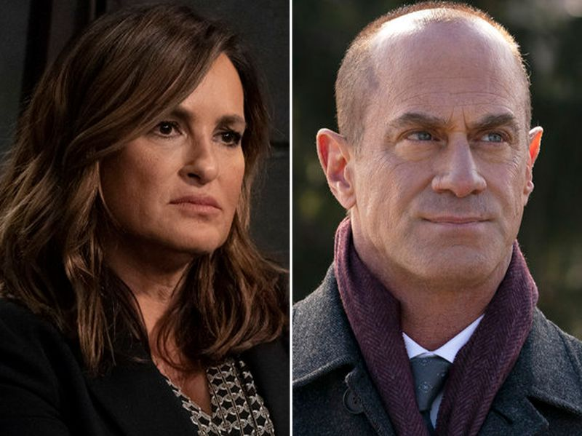

Mariska Hargitay as Captain Olivia Benson and Christopher Meloni as Detective Elliot Stabler

The two-hour event kicks off at 9 p.m. ET on NBC, and continues through the “Organized Crime” 10 p.m. slot.

According to the network, “Elliot Stabler returns to the NYPD to battle organized crime after a devastating personal loss. Stabler will aim to rebuild his life as part of a new elite task force that is taking apart the city’s most powerful criminal syndicates one by one.”

[[More Snyde] Former Panic! at the Disco bassist arrested on drug charges »](https://www.nydailynews.com/snyde/ny-panic-disco-wilson-drug-arrest-20210207-etrrum5mfvbuvn7lknkjzx5g2u-story.html#nt=interstitial-auto)

Hargitay and Meloni starred together on the first 12 seasons of “SVU” from 1999-2011.

During the season 13 premiere, Stabler abruptly retired from the force, off-camera.

In 2019, Hargitay, who now portrays the police captain, became the longest running cast member of the longest running drama in primetime history.

## [**Karu F. Daniels**](https://www.nydailynews.com/ny-karu-f-daniels-staff.html#nt=author-bio)

New York Daily News

CONTACT

Karu F. Daniels has written for the Daily News since 2014. His work has also been featured in the Associated Press, The New York Times, CNN, ABC News, Billboard, NBC News, The Daily Beast, Playbill and Word Up magazine, among other outlets.